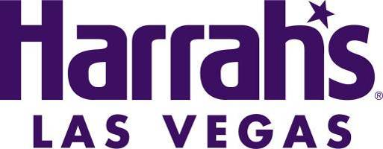

HARRAH’S LAS VEGAS FACT SHEET
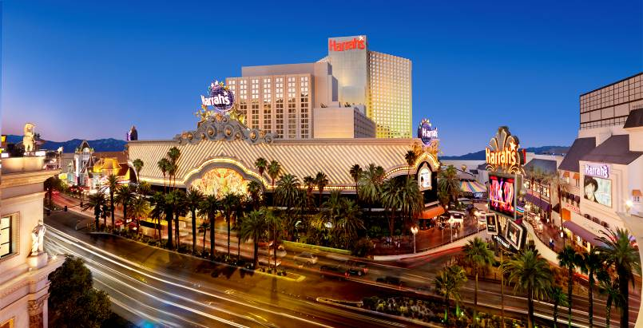
LOCATION
Harrah’s Las Vegas
3475 Las Vegas Blvd. South
Las Vegas, NV 89109
702-369-5000 or 800-214-9110
www.harrahs.com
www.facebook.com/harrahsvegas
www.twitter/com/harrahsvegas

MEDIA ROOM
http://caesars.mediaroom.com/
Harrah's Las Vegas Exterior

HISTORY
The resort opened July 2, 1973 as The Holiday Casino. It became Harrah’s Las Vegas in 1992.

OVERVIEW
Known as the fun place to play, Harrah’s Las Vegas is located at the heart of the Las Vegas Strip on 17.3 acres of land. The hotel sits across the Strip from Caesars Palace and adjacent to The LINQ Hotel & Casino and the High Roller observation wheel.

ROOMS
Harrah’s offers 2,530 guest rooms and suites, many of them newly renovated.

The Valley Tower (formerly the Carnaval South Tower) underwent a $140 million full tower renovation from 2015 to late 2017, including 1,622 new guest rooms and suites. The renovated tower welcomed its first guests in February 2016.
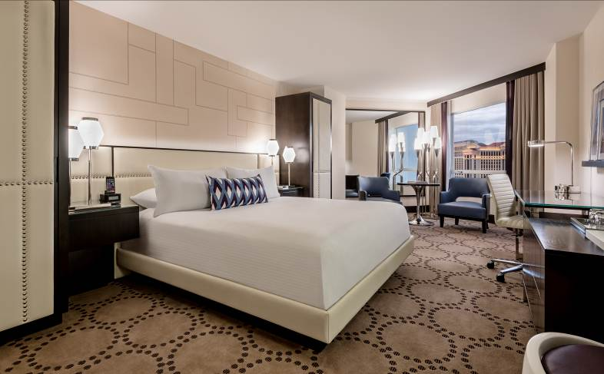
Designed by Diana Sin of Marnell Architecture, the classically inspired yet modern interiors of the reimagined Valley Tower rooms consist of a bold yet sophisticated décor with warm tones of gray and purple accents. Bold purple fabric and blue sitting chairs playfully stand out against the room’s creamy décor, dark wood accents and contemporary fixtures. A vanity offers a backlit mirror and bar, while suites feature ceramic dark plank tile.
Valley Tower King Room
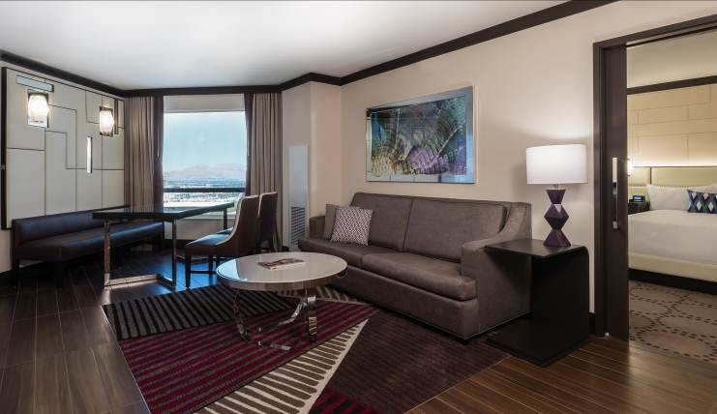
The Executive Suite in the Valley Tower features a separate bedroom, bar sink with mini fridge, dining area and living room with an electronic docking station. Starting at 600 square feet, this suite offers a luxurious bathroom with ceramic dark plank tile, a vanity and whirlpool tub. Guests have the option to expand the suite by purchasing a connecting room with two queen beds.
Valley Tower Executive Suite

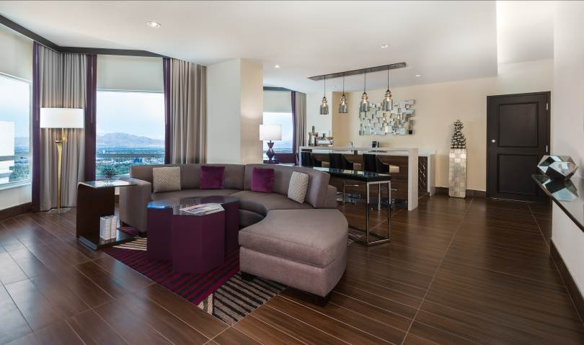
Part of the Caesars Suites collection, the new Vice Presidential Suite starts at 870 square feet, featuring a bedroom with a King bed, a living room with sofa bed, dining room, wet bar sink with mini fridge and entertainment area. The luxurious bathroom also offers a whirlpool tub. Guests have the option to expand the suite by purchasing a connecting room with two queen beds.

Measuring 1,700 square feet, the stylish new Valley Presidential Suite includes an open living space and high-end bathroom features like a walk-in rain shower, creating a spa-like experience for guests. Other amenities include a coffee maker and an oversized vanity area. This suite comes with the option of adding a connecting room with one king bed.
Valley Tower Vice Presidential Suite

The remodeled Valley Penthouse measures more than 2,000 square feet. The spacious living area features a double-sided ottoman and a full-sized bar. Pops of teal and purple combined with metallic accents give this superstar suite a bold, stylish kick. Other features include a game table and back-to-back bathroom sinks separated by a two-way mirror.

CASINO
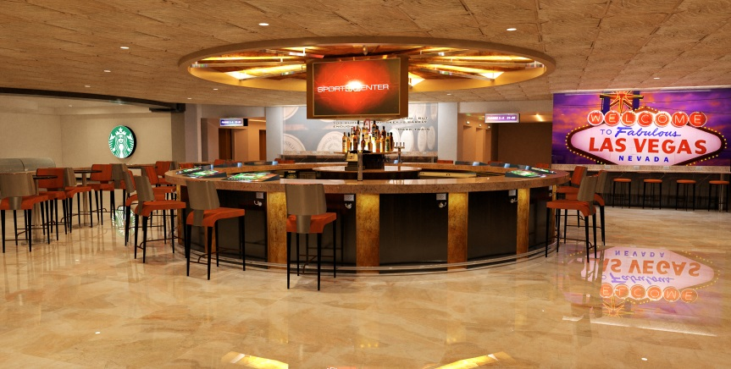
More than 87,000 square feet of classic casino space showcase the hottest slot machines, including the popular “Blazing Sevens,” million-dollar keno, blackjack, Caribbean stud poker and craps. Harrah’s caters to every player on every level, with 1,381 slot machines and 90 table games. The 24-hour live keno action takes place in the comfortable Keno Parlor. Keno can also be played while relaxing in the hotel room. The poker room features 12 poker tables.
Rendering of new Harrah’s Hotel Lobby Bar
SPORTS BOOK
Offering more than 40 HDTVs, two giant screens, continuous betting action, seating for 45 and a full-service bar, the recently renovated Race & Sports Book is the place to be for lovers of any and all sports. The venue features a modern design with rich burgundy and brown colors accenting the contemporary furniture.

MEETING SPACE
More than 24,000 square feet of flexible banquet and meeting space encompasses the Harrah’s conference space, designed to hold one large meeting of up to 1,300 people with 12 breakouts and an office, or a variety of small and medium sized meetings. Harrah’s specializes in servicing more intimate groups that require extra attention. All of the rooms are equipped with power outlets on the floor, drop down screens, full audio/visual and Internet services.

ENTERTAINMENT
Piano Bar:

Big Elvis
Big Elvis performs all the hits of the King of Rock & Roll, as well as other popular tunes in the genres of rock, country, gospel, R&B and pop spanning six decades of music. Big Elvis interacts with his audience, invites them to participate in his show and performs requests, including both popular and obscure songs. During his renditions of Elvis ballads, Big Elvis shows his warm heart and bares his soul to the extent that there is not a dry eye in the room.

Harrah's Cabaret:

Menopause The Musical
Four women at a lingerie sale have nothing in common but a black lace bra AND memory loss, hot flashes, night sweats, not enough sex, too much sex and more! This joyful musical parody set to classic tunes from the ‘60s, ‘70s and ‘80s will have you cheering and dancing in the aisles! Join the sisterhood and see what 11 million women worldwide have been laughing about. Menopause The Musical® is Las Vegas’ longest-running musical. Men love it too!

X Country
A Kick’n topless revue featuring a combination of traditional and modern country music chart toppers, X Country will showcase stimulating performances from the X Country Girls, who will leave nothing to the imagination. True to the X brand, the X Country Girls are the most beautiful and talented on the Las Vegas Strip, who will tease and seduce the audience to country music’s most popular songs!

Harrah’s Showroom:

Mac King
Mac King’s unique act contains an unusual combination of quirky humor, visual gags and astounding sleight of hand. King is known for his engaging personality and original magic creations, like making a live goldfish appear over an audience member’s head. Because of his quick wit and extensive audience interaction, no two shows are alike.

The Righteous Brothers
Get ready to have “The Time of Your Life” as The Righteous Brothers featuring Bill Medley with Bucky Heard bring the legendary sound of “blue-eyed soul” to the Las Vegas stage. Heard’s reputation as a gutsy rock and roll singer with an incredible vocal range, paired with Medley’s recognizable baritone voice and iconic songwriting talents, make for a one-of-a-kind rock and roll show.

Tenors of Rock
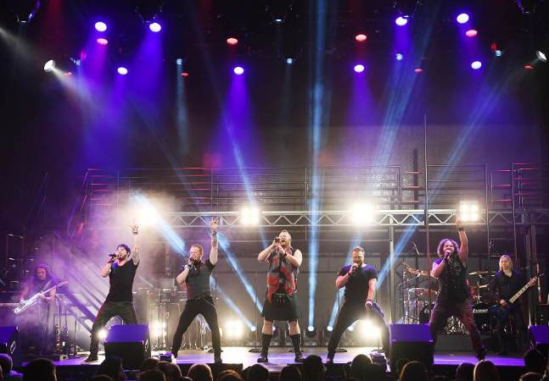
Get ready to rock like never before with an all-new, redefined concert experience that transcends generations. TENORS OF ROCK are bringing reimagined versions of some of the most beloved rock anthems and biggest songs of all-time to life in a fresh twist on the traditional rock show at the heart of the Las Vegas Strip. Powered by five burly British frontmen backed by a full band and masterfully choreographed dancers, the all-new production will feature dynamic and harmonically complex renditions of treasured songs from iconic groups like Aerosmith, Queen, AC/DC, Bon Jovi, The Rolling Stones, and more.
Tenors of Rock at the Harrah's Showroom

NIGHTLIFE
Carnaval Court
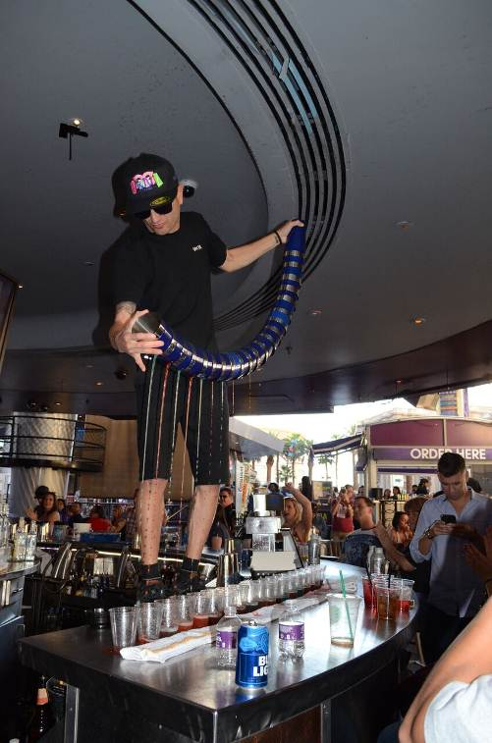
Carnaval Court is an open-air street party under the big top at the center of the Strip. Day and night, you can enjoy music from live bands and DJs who keep the lively, diverse crowds smiling and grooving. Charismatic flair bartenders dazzle as they prepare your drinks, and you can even test your luck at blackjack tables.

Numb Bar
Numb Bar & Frozen Cocktails is located on the casino floor at Harrah’s Las Vegas, just steps from the Strip. Numb offers frozen drink choices from classic Margaritas to the Up All Night, an energy drink into which the alcohol is poured both on bottom and top. There’s also beer on tap, in bottles and in souvenir glasses.

Signature Bar
You won’t be able to miss this bar, with an elegant yet eye-popping back bar display of a white onyx, lit by brilliant color-changing lights. Huge TVs, a crystal chandelier and an array of 16 cold draft beers on stainless steel tap catch the attention of any passersby. Signature Bar is the ultimate meeting place. Open 24 hours, the action will never stop.
Carnaval Court Flair Bartenders

DINING
Flavors Buffet
Flavors Buffet is one of the most diverse buffets on the Strip featuring cuisines from around the world. Guests can feast on Brazilian barbeque, pizzas and Italian casseroles prepared in a wood-burning oven, fire-roasted rotisserie chicken, piping hot snow crab legs, traditional Southwestern dishes and tasty Asian selections including hand-rolled sushi, Maki Rolls and homemade wonton soup.

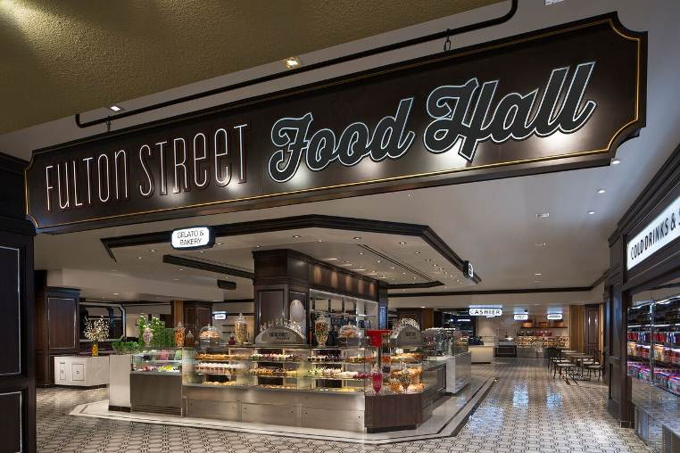
Fulton Street Food Hall
Offering a variety of dining options including bakery-fresh pastries, homemade soups and comfort foods, artisanal sandwiches, authentic sushi and noodles, New York-style pizza, Fulton Street Food Hall is the first of its kind to hit the Strip. Nine distinct stations feature chef inspired creations made with fresh ingredients. Open 24 hours, seven days a week, guests can now experience fresh, quality food at any time of day. Guests can also enjoy a sit-down, off-the menu breakfast from 6-11:30 a.m. daily. Additionally, Fulton Street recently debuted a new taco and burrito station. Menu items include authentic tacos, burritos, nachos and more.
Fulton Street Food Court

Oyster Bar
Seafood-lovers from around the world appreciate the delicious assortment of fresh seafood offered at Oyster Bar, voted “Best Seafood of 2016” by the readers of the Las Vegas Review-Journal. Guests can sip cocktails and enjoy specialty dinner entrées, which include high-quality lobster, crab, shrimp, clam chowder and calamari. Non-seafood and vegetarian entrées are also available.

Ruth’s Chris Steak House
This unique location boasts the restaurant's signature sizzling steaks in a setting of floor-to-ceiling windows that showcase the panoramic views of the Las Vegas Strip. Menu items include USDA Prime steaks, appetizers and delectable desserts; all complemented by an award-winning wine list and handcrafted cocktails. Private dining is also available.
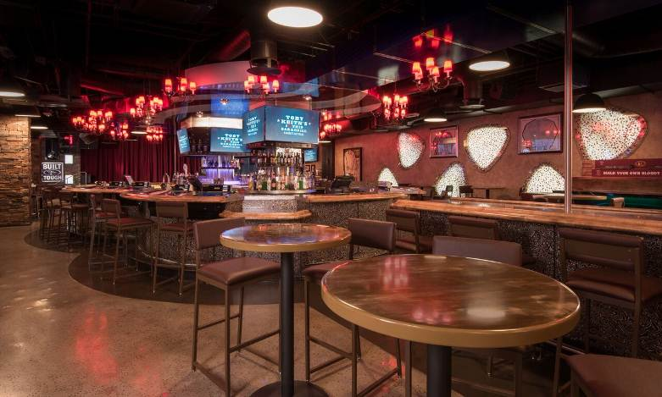
Toby Keith’s I Love This Bar & Grill
Toby Keith’s Bar & Grill features a bar, lounge, restaurant, live music venue and retail store, all of which offer the finest in American food, spirits, entertainment and merchandise. The true southern-home style menu features the country star’s favorite mouth-watering recipes such as the “Old West” BBQ bacon burger, the homemade honky tonk meatloaf and the world famous fried bologna sandwich. Live country music acts, hand-picked by Toby Keith, play nightly starting at 9 p.m. with no cover. Guests can also celebrate the weekend with Toby Keith’s “Hangover Sundays,” which features a build-your-own-Bloody Mary bar, mimosas and live acoustic bands from 1-4 p.m.
Toby Keith's I Love This Bar & Grill

Ben & Jerry’s
Want to have your Ben & Jerry's ice cream the way it was originally intended? Head to our ice cream shop, up the escalator on the 2nd floor, and dig into any of our euphoric ice cream flavors in the way the first scoops were served up by Ben and Jerry back in 1978. We also offer sundaes, shakes and smoothies, plus freshly made waffle cones!

POOL
Debuted in summer 2015 following a major overhaul, the renovated outdoor Pool at Harrah’s Las Vegas provides the ultimate relaxation and recreation experience. Enjoy comfortable lounge chairs and daybeds, poolside cocktails and meal service, as well as a poolside café. Private luxurious cabanas are available for rent by the day and include a refrigerator, phone, TV, fruit basket, juice and water, a newspaper, towels, and a raft. The new wading pool features loungers situated right in the water for the ideal cooling relaxation experience. Guests can also play a life-size game of chess right on the new travertine tile pool deck. The pool is open seasonally for hotel guests only.

SPA & SALON
Located on the resort’s fourth floor, the Spa at Harrah’s Las Vegas is a professionally staffed facility that offers a special getaway where guests can be pampered, melt away any stress and enhance overall well-being. Guests can luxuriate in an aromatherapy treatment, Swedish massage or facial treatment, which promote the release of stress. Additionally, the health club features the latest cardio equipment and weight machines. Visitors have the opportunity to relax in the steam room, whirlpools and saunas as well. Open daily, the spa provides towels and private locker rooms for convenience.

Harrah’s also features a full-service beauty salon offering a wide range of services. Appointments are available for a haircut and style, manicure and pedicures, and make-up application.

###

