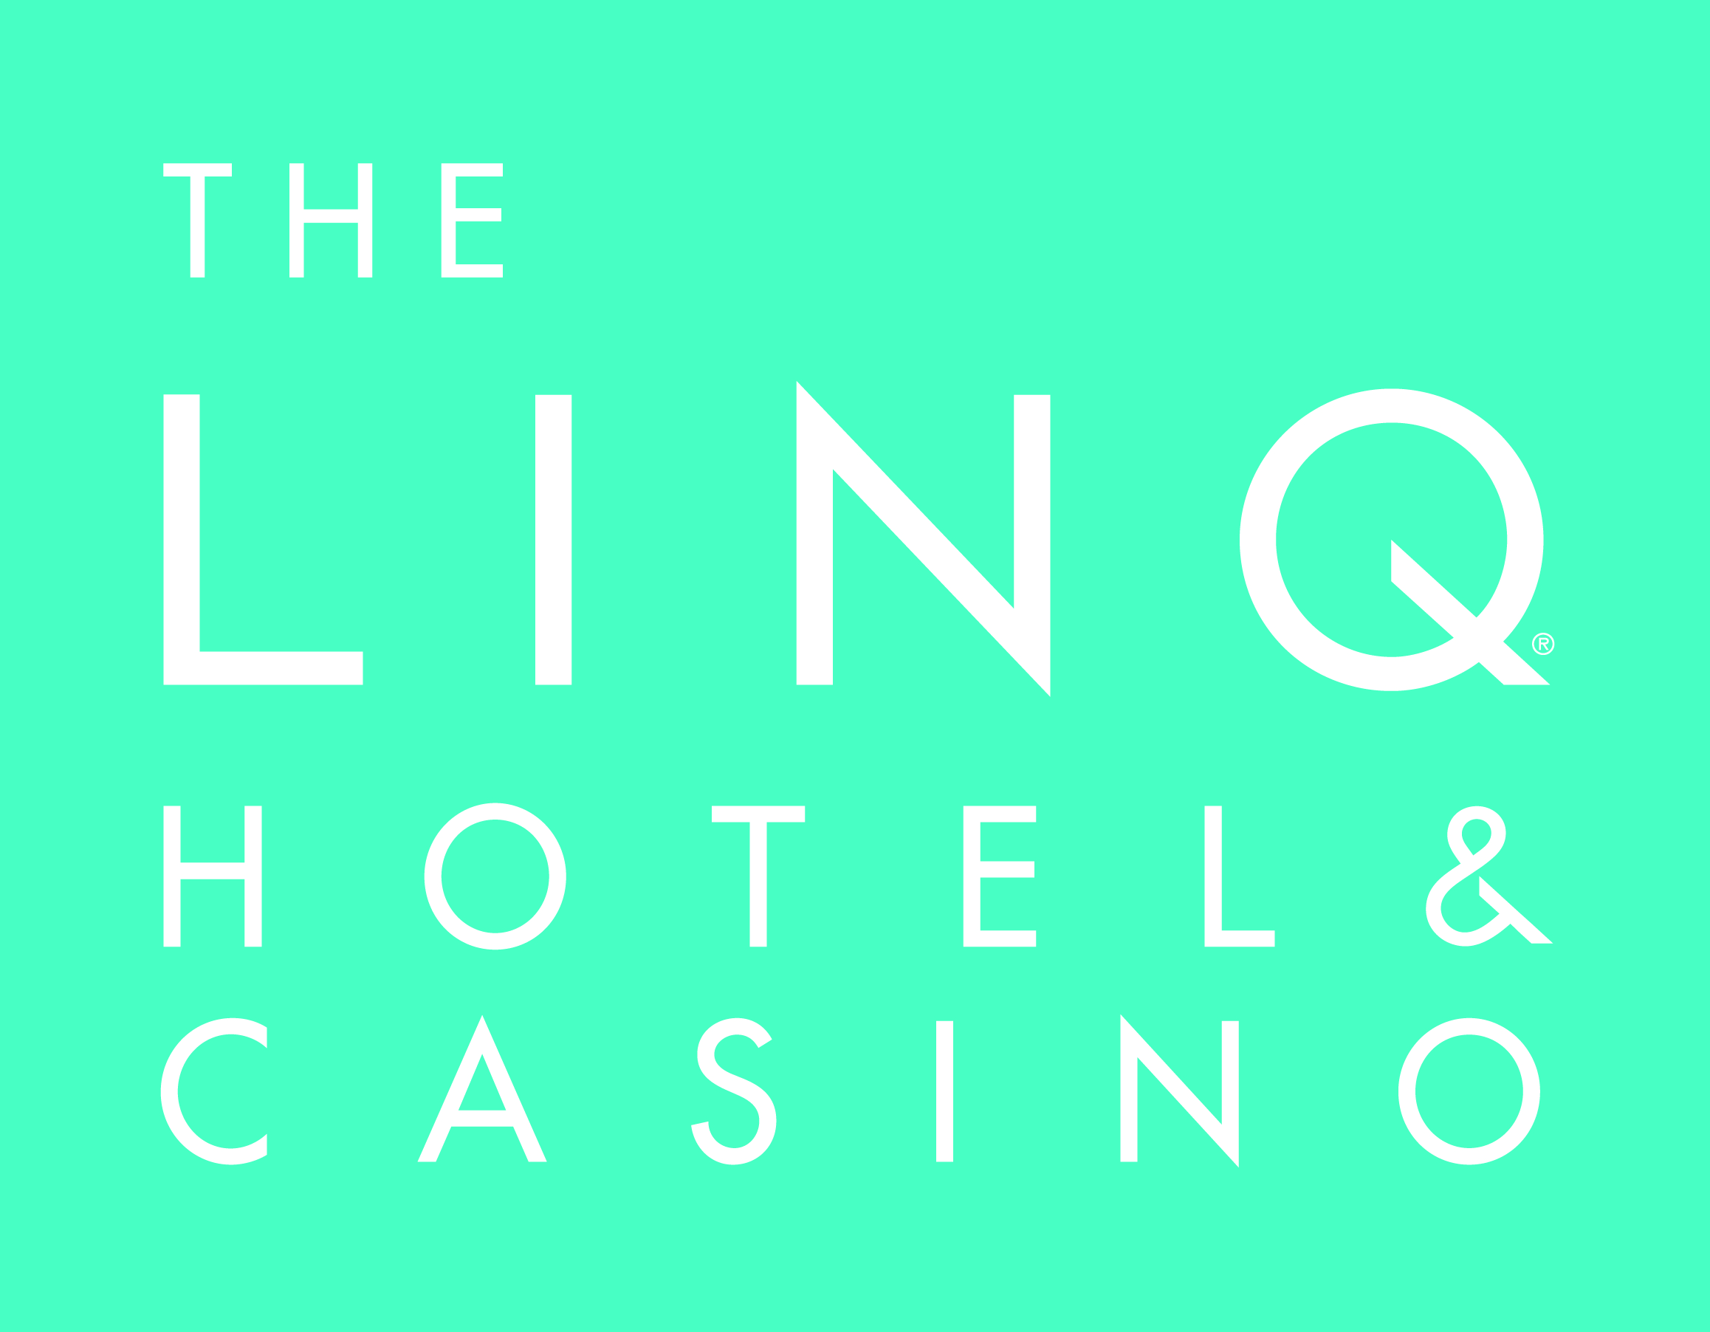

LOCATION The LINQ Hotel & Casino
3535 Las Vegas Boulevard South
Las Vegas, NV 89109
1-800-634-6441
TheLINQ.com
Facebook.com/TheLINQ
Twitter.com/TheLINQ
Instagram.com/TheLINQ

MEDIA ROOM http://caesarslasvegas.mediaroom.com

OVERVIEW

The LINQ Hotel & Casino features 2,253 rooms, including the first bunk bed rooms on the Las Vegas Strip and 244 suites with two unique penthouses and 25 poolside cabana rooms. The expanded 21-and-over POOL at The LINQ features two pools with life-sized games and beer pong, DJs seven days a week, and food and cocktails.

A modern Las Vegas hotel created with the connected traveler in mind, The LINQ Hotel & Casino features unique elements such as a fully-integrated self check-in/check-out program, touchscreen directories, way-finding systems and electric vehicle charging stations. The convenient center-Strip location of the resort also offers guest access to The LINQ Promenade is a 300,000 square foot leasable and common space featuring more than 30 shops, restaurants and entertainment venues, along with the High Roller - the world’s tallest observation wheel at 550 feet.

The hotel also features the 15,000-square-foot Spa at The LINQ and fitness center, located on the sixth floor of the main guest elevators. The state-of-the-art spa offers the only Himalayan Salt Cave therapy room on the Strip, as well as relaxation lounges, steam rooms and whirlpool areas.

CONVENTIONS

The LINQ Hotel & Casino features 63,000 square feet of flexible meeting and event space. The Vortex, a reimagined rooftop deck overlooking the Las Vegas Strip, offers 20,000 square feet of customizable outdoor space for private events such as cocktail receptions and concerts. Experience the spectacular views from the adjacent 18,000-square-foot Bloq indoor ballroom with floor-to-ceiling windows. A diverse array of facilities—from intimate meeting rooms to The Showroom—provide for gatherings of all types and budgets.

SELF CHECK-IN/CHECK-OUT KIOSKS

Caesars Entertainment launched the first fully-integrated self check-in/check-out kiosks on the Strip at The LINQ Hotel & Casino in 2015. The program incorporates email, text, web, mobile app and kiosks, completely reinventing the way guests arrive and begin their stay. Upon arrival, guests can proceed immediately to the check-in kiosk to begin their check-in process, verifying their IDs and taking payment information right at the machine and either receive a printed key if their room is ready, or if it is not set up, receive an alert to return when their room becomes available.

Additionally, guests who book their reservation directly through TheLINQ.com have the ability to begin their check-in process at home, either through the web or through Caesars Entertainment’s “play by Total Rewards” mobile application, and receive a notification to proceed to the kiosk to get their keys when their room is ready.

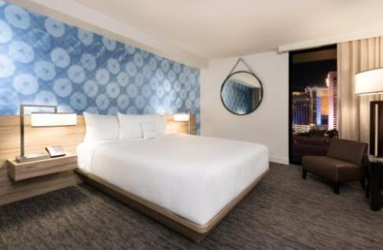
ROOMS & SUITES

The Deluxe Room, ranging from 250-400 square feet, features a fresh, modern design with floor-to-ceiling windows, boasting views of the iconic Las Vegas Strip or the High Roller, the world’s largest observation wheel. The centerpiece of the room design are three distinct accent wall backdrops featuring stylized renderings of vintage Las Vegas signage, providing guests with a unique experience each time they visit the hotel.

Deluxe Rooms include:
- Beds with lush pillow-top mattress and oversized pillow
- 47-inch LCD flat-screen TV
- USB charging station located at the convenient in-room compact commuter workspace
- Bathrooms with marbled sink and overhead rain shower
- High speed Wi-Fi available throughout the resort in all common areas, hotel rooms and gaming floor
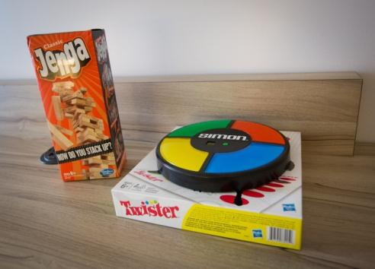
- All hotel rooms and suites will have access to the SONIFI system on the television which gives guests access to all of the hotel amenities. With the click on the TV remote, guests can order room service, set up an alarm clock and more. Guests can also access the SONIFI system from their personal smart phones and personalize their music experience with customized LINQ Hotel playlists on Spotify.
- Guests can also rent board games including: Twister, Cards Against Humanity, Simon, Yahtzee and Jenga.
- Work out from your room – The LINQ Hotel & Casino features complimentary in-room fitness carts for hotel guests from 7 a.m. to 7 p.m. daily. The carts include yoga mats, stability balls, fitness discs and foam rollers for a four-hour rental period. Hotel guests can call or visit Spa at The LINQ to make a reservation for the delivery.

Suites:
King Junior Suite
Approximately spanning 600 square feet, the King Junior Suite features all the amenities of a standard King room, plus a bit more space. Electronic features include two charging stations with USB ports, an iPod/iPad docking station and one 47-inch LED flat-screen TV. The room is designed with light, modern furnishings and pops of color. Each suite comes with microfiber robes and slippers.

King Suite
The 600-square-foot King Suite features all of the space of a Deluxe King room, plus a separate living area. This suite offers one king bed with a pillow-top mattress. Electronic features include two charging stations with USB ports, an iPad docking station and two LED flat-screen TVs – a 55-inch TV in the living room and a 47-inch TV in the bedroom. The room is designed with light, modern furnishings and pops of color. Each suite comes with microfiber robes and slippers. Room service is available.

Deluxe Queen Suite
The 701-square-foot Deluxe Queen Suite offers two pillow-top queen beds and a separate living room with sectional couch, high-top table and wet bar. The modern décor and two LED flat-screen TVs (a 55-inch TV in the living room and a 47-inch TV in the bedroom) are playfully complemented by nostalgic in-room board games.

Deluxe Poolside Cabana Room
The 300-square-foot Deluxe Poolside Cabana Room with private patio and direct pool access is the perfect spot to soak up the sun on your Vegas vacation. Skip the lines at the dayclubs and party on your private patio then get a quick dip in at the Pool at The LINQ. Cabana room guests enjoy waitress service from the nearby pool bar. The room also features 47-inch flat-screen TV and USB charging stations to keep devices charged for all those poolside pics.

The LINQ Penthouse
Upgrade to a 1,067-square-foot penthouse party pad with one of the two LINQ Penthouse Suites. It’s like stepping into an art gallery with eclectic wall art and unique furnishings including a chaise that demands to be in your next profile photo. Crank up the Bose speakers, play Jenga and glow-in-the-dark chess while you use the kitchenette’s spacious fridge and classy, padded leather bar to pre-game before going out. The bathroom boasts a seated vanity and walk-in rain shower. Sophistication and modern, sleek design meet in this one-bedroom suite.
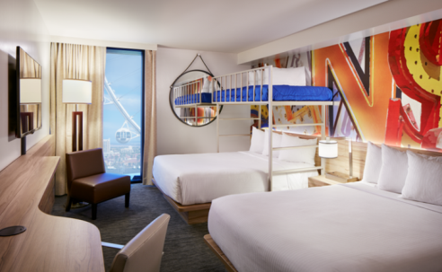
Bunk Bed Rooms:
- The twelve rooms feature two queen beds and a bunk bed loft
- Ideal for large groups of friends or families
- Rates start at $69 for the 350-square-foot room
- Electronic features include USB charging stations and a 47-screen LED flat-screen TV

DINING

Guy Fieri’s Vegas Kitchen & Bar
Open for breakfast, lunch, dinner and late night dining, Guy Fieri’s Vegas Kitchen & Bar features a delicious blend of casual foods including an extensive variety of burgers, wings, tacos, small bites and shareable food items. The restaurant’s extensive drink menu features 16 craft beers, in addition to the Sonoma County wine selection and a frozen tap system shot bar that will create a one-of-a kind experience for guests.

Hash House A Go Go
Known for its creative menu offerings, oversize portions, unique presentation and flavorful dishes using only the freshest ingredients, Hash House A Go Go offers guests an unforgettable dining experience. The menu features their spin on traditional breakfast favorites such as their signature farm scrambles, one-pound stuffed burgers, colossal salads and innovative dinner dishes such as their Andy’s crispy Indiana style hand hammered pork tenderloin.

Off The Strip
Off The Strip has something for everyone with authentic Italian favorites, steaks, chops, burgers, seafood and more. This two-story bistro features three bars and indoor and outdoor dining with a delicious variety of hearty and healthy food.

Nook Café
Nook Café at The LINQ Hotel & Casino is the perfect spot to refuel in between sightseeing with quick and fresh food including breakfast burritos, gourmet sandwiches, hand-tossed pizzas. Sit and relax or grab food to go.

Nook Express
Get your morning pick-me-up or late-night snack at the Nook Express at The LINQ. The small express eatery serves fresh, authentic assortments of coffee, teas, delicious pastries and small bites of satisfying tastiness daily.

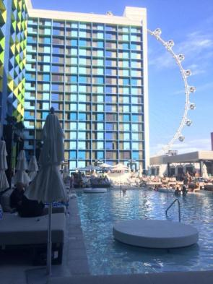
THE LINQ POOL

The LINQ Pool at The LINQ Hotel & Casino provides a cooling escape with spectacular views of the High Roller observation wheel and the LINQ Promenade. This center-strip destination features a center bar lined with plasma televisions and full of signature cocktails, draught beer, frozen drinks and more. The main pool boasts a wet deck with lily pad daybeds available for rent, while the second pool is accessed from a standalone elevated deck with tables available for rent as well.
- 24 cabana rooms line the pool, offering an exclusive patio area connecting the room directly to the pool deck. The patio area includes a plasma television, sectional seating and umbrellas to keep you shaded. As a cabana room guest, “wake-up calls” are available from the cabana staff where guests can have menu items delivered directly to them at a specified time.
- Ten cabanas available for rent which include a personal electronic safe, plasma TV, USB port for phone/music player, reserved chaise lounges and a refrigerator stocked with bottled water and RESQWATER. Cabana hosts and waitresses will provide fresh sliced fruit and veggies while the overhead misting system keeps guests cool.
- 35 daybeds line the pool deck and include a personal electronic safe, a handy compartment to keep clothing and shoes dry and umbrella holders to provide shade from the warm sun
- DJs spinning 7 days a week
- Themed days such as: Tropical Saturday, Champagne Sundays, and Two For Tuesday’s

LINQ HOTEL & CASINO POOL

Hours: 9 a.m. – 5 p.m., Prices: Free, exclusive to LINQ Hotel guests

BARS & NIGHTLIFE

3535
3535 is a trend seeker’s destination lounge, featuring a hand crafted selection of infusion cocktails; barrel aged spirits, wine by the glass and a vast selection of premium and craft beers. 3535 is an all-encompassing space with a multitude of experiences in one with casino gaming, bottle service, beverage cart offerings and a variety of entertainment including weekend DJ sets.

Catalyst Bar
Located inside The LINQ Hotel & Casino, Catalyst Bar is open around the clock and puts a spin to your traditional cocktails. For a sweet and spicy kick, try the Jal-E-Berri - muddled strawberries and jalapenos paired with Skyy vodka, fresh lime and grapefruit juices.

O’Sheas Casino
With a raucous atmosphere traditional of an Irish pub, O’Sheas is a destination that’s pure fun and features the same gaming tables, beer pong and drink specials that made the original so popular. In its heavily social and dynamic environment, enjoy more than 60 kinds of beer, table games, and a lively outdoor bar and nightly entertainment at its Irish-inspired stage area featuring live performances.

TAG Sports Bar
TAG Sports Bar at The LINQ Hotel & Casino has revolutionized the traditional sports lounge with its cutting-edge digital casino games, a beverage list of more than 300 beers and sports streaming 24 hours from around the world.

ENTERTAINMENT

Divas Las Vegas
Starring Las Vegas’ longest-running headliner Frank Marino as comic icon Joan Rivers, Divas Las Vegas at The LINQ Hotel & Casino features an all-star cast of female impersonators who recreate some of music and entertainment’s biggest superstars, ranging from Lady Gaga to Cher, Diana Ross to Beyoncé, and even Madonna and Britney Spears. Meanwhile as the show’s emcee and star, Marino brings an international whirlwind of couture to the stage with each spectacular entrance. The show features 17 different performers a night all sporting new costumes to sparkle and shine on the stage. Audiences will also experience new numbers showcasing talents from Ru Paul’s Drag Race and America’s Got Talent while surrounded by the Six of Sin City’s hottest male dancers.

Mat Franco
Mat Franco, the first magician to win NBC’s America’s Got Talent, brings his captivating, hold-on-to-your-seat illusions to the heart of the Las Vegas Strip. For his first-ever Las Vegas headlining residency, Mat offers a fresh, fun, and feel-good twist on magic that defies all expectations. In a full-scale production built on brand-new, never-before-seen material, Mat delivers his most spectacular performance yet—but still keeps his love of getting up close with the crowd at the heart of every show. With his signature brand of breezy humor, Mat mixes his amazingly inventive and always stunning magic with crowd-guided improv to create a once-in-a-lifetime adventure that’s completely unique to each audience and entirely unforgettable.

WEDDING CHAPELS

The Silver Sky Chapel at The LINQ Hotel & Casino offers two intimate indoor wedding venues, the Skyline and the Sierra chapels. The Skyline Chapel is The LINQ's signature wedding venue, with seating for 70 amid an atmosphere of romantic whimsy, featuring a 50-foot aisle and a color palette of blue, black, cream and white. The quaint Sierra chapel accommodates up to 20 for an intimate wedding in a chapel that recalls the sights of the Southwest.

ATTRACTIONS

THE LINQ PROMENADE

The LINQ Promenade is an open-air shopping, dining and entertainment district, anchored by the world’s tallest observation wheel, known as the High Roller. Located at the heart of the world-famous Las Vegas Strip and surrounded by approximately 10,000 hotel rooms, The LINQ Promenade is situated between The LINQ Hotel & Casino and Flamingo Las Vegas, directly facing Caesars Palace. An estimated 20.4 million visitors pass by this coveted space each year.

Brooklyn Bowl
Following in the footsteps of the original Brooklyn location, noted as “one of the most incredible places on earth,” Brooklyn Bowl Las Vegas is where locals and tourists go for a nightly eclectic blend of live music, 32 bowling lanes and five bars with an all-house made menu created and executed by brothers' Bruce and Eric Bromberg's Blue Ribbon Restaurants. With three levels spanning nearly 80,000 square feet, it will be one of the largest music venues in America, and will offer programming throughout the day and late into the night.

High Roller Observation Wheel
Shining bright on the Las Vegas Strip, the 550-foot-tall High Roller is the world's largest observation wheel. This stunning Las Vegas attraction provides tourists and locals alike incredible views of Las Vegas and the surrounding valley. The epic wheel is the crown jewel of The LINQ Promenade, The Strip's outdoor shopping, dining and entertainment district. The High Roller has 28 spherical, glass-enclosed cabins featuring dynamic music and video shows. Passengers take in the 360-degree sights during the 30-minute ride. Whether renting out a cabin for wedding, private party or flying solo, there are many unique ways to experience Las Vegas’s newest attraction. Guests may also enjoy the daily Happy Half Hour experience, which offers passengers access to an open bar during their ride. There's also an adjacent wheel house where guests can reserve private parties and banquets.
- Yoga in the Sky: Yoga in the Sky allows guests the only chance to find their Om while enjoying the breathtaking, 360-degree views of Las Vegas. The experience includes a one-hour yoga session (two rotations) with a Silent Savasana instructor and up to six gusts per cabin. Guests are guided through the experience by wearing a headset that allows them to hear the instructor and music. Reservations must be booked at least 24 hours in advance. Yoga is offered Sunday, Wednesday and Friday at 11:30 a.m. and 5 p.m. The pricing: $75 per person, $85 per person for sunset option. For a private, one-on-one session, the price is $250 per person or $300 per couple. Five sessions can be purchased for $325 per person.
- Chocolate Tasting: This is the only one of its kind in North America. Guests learn about the origins of chocolate and how Ethel M Chocolates’ signature varieties were created, all while focusing their attention on the aroma, taste and texture. The 30-minute (one rotation) adventure includes a chocolatier ambassador showcasing five different chocolate pieces and the story behind them. Tastings are available every Thursday, starting at 5 p.m. The price is $52 per person or $15 upgrade with current evening admission ticket or $1,500 per private cabin.

