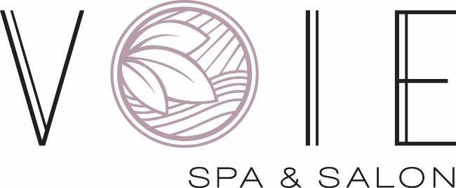

VOIE SPA & SALON FACT SHEET

OVERVIEW Voie Spa & Salon at Paris Las Vegas is a luxe 25,000 square-foot facility inspired by bountiful sensory journeys throughout regions of France. French for “way,” Voie invites visitors to indulge in premium services that infuse natural notes of France’s countryside into a decadent mind and body wellness experience.
Set in elegant harmonious backdrop, Voie offers a wide range of treatments that include specialized bathing experiences to detoxify the body, signature sound therapy massages, and hydra-cleansing treatments tailored to individual needs.
Renovated and reopened in 2019 with a total investment of $3.75 million, Voie mixes therapies, senses, and tastes to create a unique experience and set guests on their path to wellness.
LOCATION Voie Spa & Salon is located on the second floor of Paris Las Vegas.
HOURS The spa is open daily from 8 a.m. to 7 p.m., and the gym is open daily from 6 a.m. to 7 p.m.
WEBSITE VoieSpa.com
AMENITIES Voie features multiple amenities including men and women’s relaxation lounges with an aroma steam room, whirlpools, lockers, snacks, showers, a fitness room, hydrating libations and weekly events and activities. Guests can also enjoy two sound therapy rooms, a spray tanning room and six Couple’s Suites.
Hotel guests who book a spa or salon treatment on their first day will receive a complimentary take-home Voie gift.
SALON BOUTIQUE A chic full-service salon is available to guests who opt for individual hair care services. Whether it’s a chic hair-cut, a cooling mint and eucalyptus treatment, a mani-pedi, or a voluminous blow-out, visitors will walk away with a look à la mode.
BRIDAL & GROOM Couples can embark on a harmonious journey by indulging in a
SERVICES specialized series of treatments that extract influences from France
to prepare for the big day.

Brides can book a consultation with skilled artisans to create the perfect bridal style or restore hair suppleness with a nourishing scalp ritual. On the wedding day, guests can treat their skin to the only hydra dermabrasion treatment that provides cleansing, exfoliation, hydration and antioxidant protection for radiant, supple skin. Visitors then relax with their significant others with a body mask enriched with iridescent minerals and detoxifying flower or a mineral-enriched bath combined with Voie’s signature sound therapy treatment.

COUPLE’S SUITES Voie features six luxurious Couple’s Suites that encourage couples to immerse themselves in lavish tranquility. The suites are fashioned to fit a variety of spa services at the guests’ request.

SIGNATURE Using customized French blends, Voie provides visitors with a
TREATMENTS collection of signature treatments designed to transport guests to a state of luxurious relaxation.

Voie’s Bordeax Caviar Hydrating Mask combines rich source vitamins of roe extract with marine DNA to hydrate and smooth fine lines. Enhance the skin with the LED Light Therapy treatment that emits UV free light rays that energize cells, build new proteins, and regenerate cells.

Visitors can opt for one of Voie’s bathing experiences that oxygenate and remineralize the body, improve blood flow and promote deeper relation to provide relief for tired muscles and minds.

Voie invites guest to disappear to the aromatic landscapes of France with the Voie Luxe Escape, a phyto-aromatic journey that is uniquely different each time it’s experienced. Guests can soak in a thalassotherapy bath and enjoy a personalized exfoliation treatment based on skin-type. Follow with a French regional scent of choice and a custom rose-colored pink salt stone massage. The journey ends with being cocooned in a comforting wrap with a Dijon Milk and Honey Mask and rejuvenating scalp treatment.

