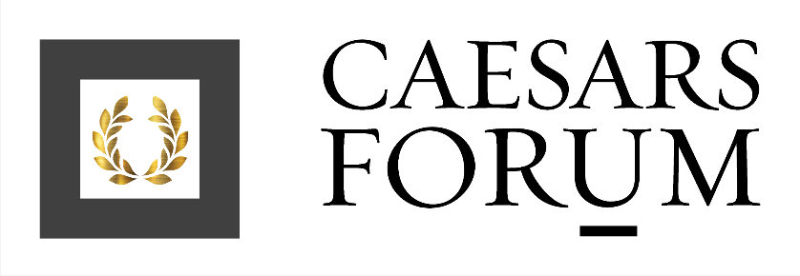
Top Ten Facts

Opened on March 18, 2020, CAESARS FORUM is a $375 million conference center that has redefined both practical and aesthetic offerings for meetings and events in Las Vegas.

- Located in the center of the Las Vegas Strip, CAESARS FORUM provides direct access to 8,500 hotel rooms at its nearby sister properties - Harrah’s Las Vegas, The LINQ Hotel + Experience and Flamingo Hotel - as well as access to the LINQ Promenade’s entertainment, retail, and dining options within just a short walk of the conference center.
- The 550,000 square-foot conference center is the first facility of its size to be built on a single level. This unique facility can accommodate up to 10,000 participants at one time.
- CAESARS FORUM’s name and conception was inspired by the Roman forums, ancient places of gathering.
- The conference center is home to the two largest pillarless ballrooms in the world: Forum and Summit Ballrooms. Each ballroom has 110,00 square feet of meeting space and can fit one football field in length. With over 2.1 miles of airwalls, CAESARS FORUM can be divided into limitless configurations.
- Forum Plaza, which has direct access to CAESARS FORUM, is the only 100,000-square-foot, dedicated outdoor meeting and event space in Las Vegas.
- CAESARS FORUM offers six 1,250-square-foot beautifully appointed boardrooms providing full privacy as well as intelligent glass control with options such as frosting the glass when a meeting is in progress.
- CAESARS FORUM has a biophilic design featuring nature inspired elements as well as spacious and open floor plans with direct access to the outdoors. The pre-function space has an organic feel with tall windows, plenty of natural light and large glass doors opening onto Forum Plaza – perfect for coffee breaks and cocktail receptions.
- Since opening, CAESARS FORUM has been selected for the following meetings industry annual meetings: ConferenceDirect’s annual partner meeting, HelmsBriscoe ABC, Cvent Connect, MPI WEC and PCMA’s Convening Leaders.
- In 2022, CAESARS FORUM and the city of Las Vegas was honored to host the NFL Draft.
- CAESARS FORUM is in the process of being Leed GOLD certified and is estimated to be 44% more water efficient than buildings of a similar size. This efficiency will save 4.6 million gallons of water per year – equivalent to seven Olympic-sized swimming pools.

