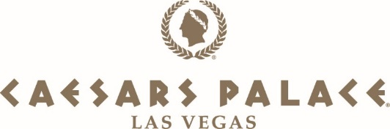

New Luxury Villa Amenities Fact Sheet

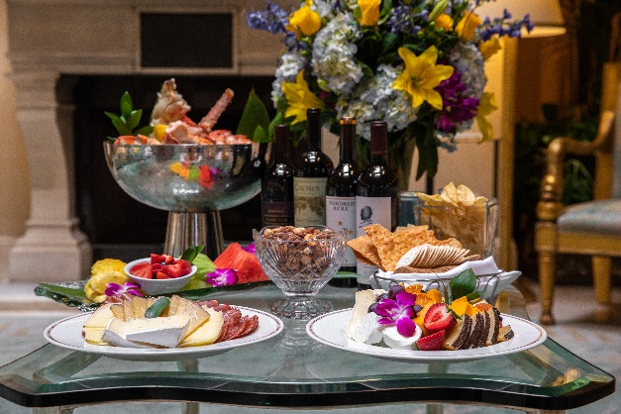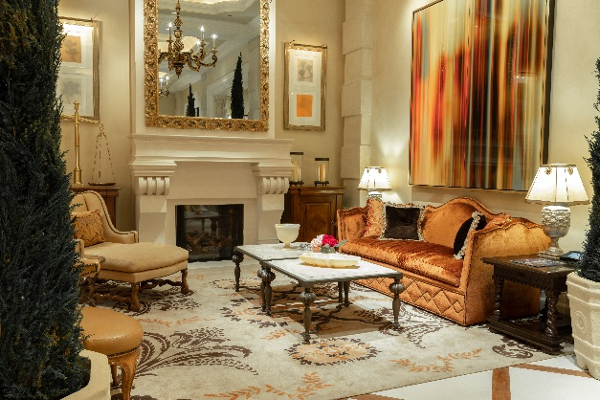
Luxury Villa Amenities at Caesars Palace Las Vegas

**For high-res photos and videos, click here**

Caesars Palace Las Vegas is known worldwide for its collection of 25 opulent villas, which have hosted some of the world's most notable guests including celebrities, dignitaries and royalty. Villa guests experience the ultimate VIP treatment, from lavish upgrades and amenities to an around-the-clock butler who speaks their language of preference. Caesars Palace has recently added a variety of amenities for luxury travelers that are now included in the cost of booking a villa, rather than an additional expense. The amenities vary based on the guests’ length of stay and the type of villa they book. Examples of new villa amenities include continental breakfast with caviar and Cristal Champagne, a seafood display for four and Rolls-Royce chauffeur service to and from the airport. Starting rates for villas range from $15,000 per night to $30,000 per night.

Additionally, jetsetters looking for a much-needed zen retreat with unparalleled views of the Las Vegas Strip can book the all-new Nobu Villa Wellness package at the world’s first Nobu Hotel, located inside Caesars Palace. For $35,000 per night, this exclusive package includes accommodations for four in the sprawling, 10,300-square-foot Nobu Hotel Villa with butler service and roundtrip airport transportation in a Rolls-Royce. Designed by the Rockwell Group, the Nobu Villa offers a relaxing, modern atmosphere with a warm wood, bronze finishes and custom furnishings.
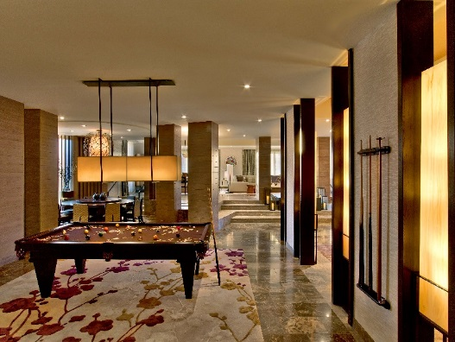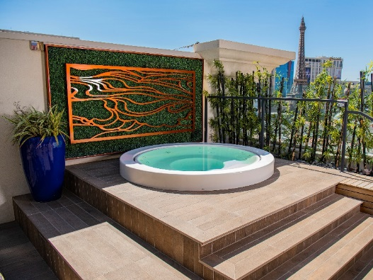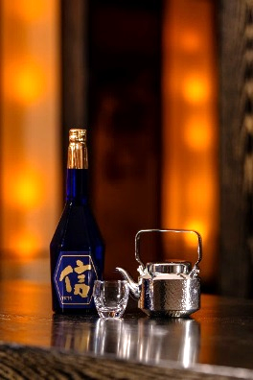
Nobu Villa Wellness Package at Nobu Hotel Caesars Palace

Upon arrival for the Nobu Villa Wellness experience, guests will be welcomed with a bottle of Chef Nobu’s Hokusetsu Daiginjo YK-35 Enshinbunri premium sake; various platters of cheeses, sliced fruit and charcuterie; chocolate-covered strawberries and assorted beverages. Guests can unwind in the Japanese-inspired onsen tub on the expansive rooftop terrace or enjoy the sauna and elevated round soaking tub in the master bathroom. For a healthier breakfast, the curated selection will include Nobu caviar, avocado toast, Greek yogurt parfaits with homemade granola, mini soba pancakes with blueberry compote and seasonal sliced fruit, green tea mango low-fat smoothies and açai punch. Guests will also detox and relieve stress with 50-minute Nobu Zen massage treatments for four at Qua Baths & Spa inside Caesars Palace. The Nobu Villa Wellness package is available now through Dec. 23, 2021.

Through the recently launched Caesars Suites program, guests can experience these extravagant accommodations and amenities only previously available to the highest level of casino guests, including celebrities and “high rollers.” More than 2,000 Las Vegas suites and villas are available to view and book online at caesarssuites.com – from sleek, multi-room suites that start at $175 per night to grand villas spanning nearly 11,000 square feet for $35,000 per night.

