Eiffel Tower Viewing Deck & Light Show Fact Sheet

OVERVIEW:
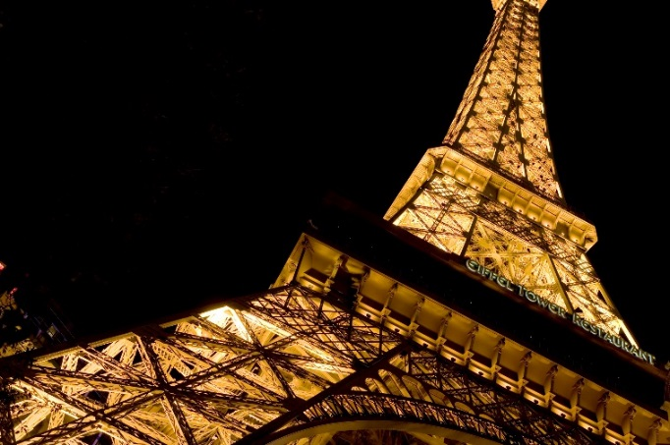
Rise above the frenzy of the Strip at one of Las Vegas’ premier attractions with amazing views. An icon of the city skyline, the high-altitude attraction is located 46 stories up and is a half-scale replica of the world-famous Paris, France landmark. The viewing deck features 360-degree city views and knowledgeable Ambassadors point out Las Vegas landmarks. The views of the bright, colorful lights are unmatched.

FACTS:
- Height: 541 feet, 164.6 meters
- Weight: 5000 tons of wielded steel
- Cost: $28 Million
- Opened: September 1, 1999
- Construction time: 18 months

HISTORY:
Ground broke for the Eiffel Tower Viewing Deck at Paris Las Vegas on April 17, 1997. It officially opened September 1, 1999. When the scale model of the Eiffel Tower was built, it was planned to be full scale, but the airport was too close and the tower had to be shrunk. The scale is approximately one half. The Eiffel Tower is 541 feet tall, 164.6 meters. It is made up of 5000 tons of wielded steel and is tallest replica of the original Eiffel Tower to date. The observation deck stands at 460 feet high. A custom designed crane, the largest in the United States, was needed to assist in construction. It cost $28 million to construct the half scale replica of the original and took 18 months to complete.

AWARDS:
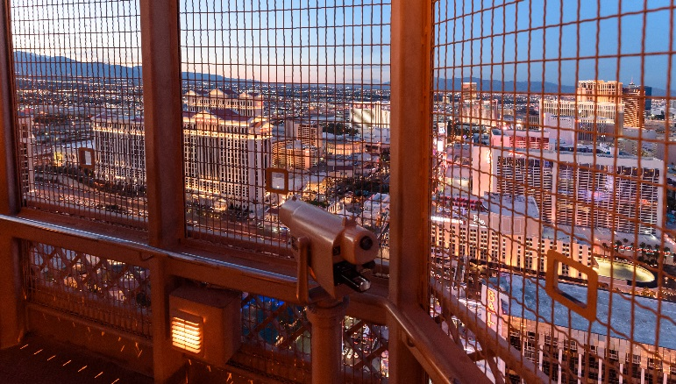
- Best of the City 2016 – Vegas SEVEN
  - Best Tour Guide: Vearn Rogers
- Best of Las Vegas 2016 – LVRJ
  - Best Romantic Spot (Bronze)
- Best of Las Vegas 2017 – LVRJ
  - Best Romantic Spot
- TripAdvisor 2014 Winner
  - Certificate of Excellence
- TripAdvisor 2015 Winner
  - Certificate of Excellence
- TripAdvisor 2016 Winner
  - Certificate of Excellence
- TripAdvisor 2017 Winner
  - Certificate of Excellence
- TripAdvisor 2018 Winner
  - Certificate of Excellence
- TripAdvisor 2018 Winner
  - Hall of Fame Award

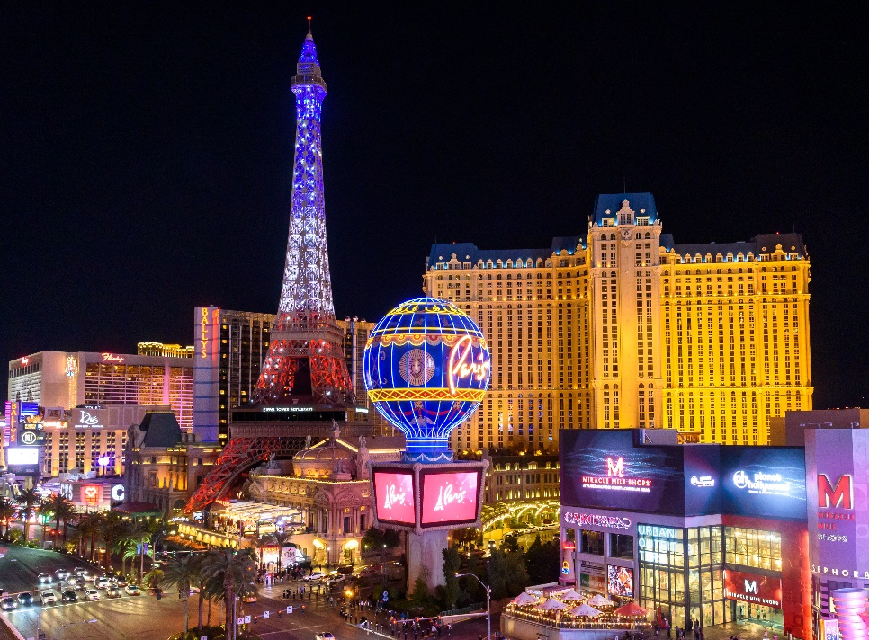

EIFFEL TOWER LIGHT SHOW:
Paris Las Vegas illuminated the Las Vegas Strip with the debut of a $1.7 million light show at the Eiffel Tower on Feb. 27, 2019. Inspired by the Eiffel Tower’s illuminations in France, the enhanced lighting at the Paris Las Vegas attraction offers a free, recurring show featuring synchronized and choreographed twinkling and colored lights for visitors to enjoy nightly on The Strip. In partnership with Vision Sign Inc., Paris Las Vegas installed approximately 300 color washing light fixtures and more than 800 white strobe lights on the tower’s exterior. Guests can enjoy the nightly light show every 30 minutes on the hour and half hour from sunset to midnight.

GENERAL INFORMATION
Paris Las Vegas
3655 Las Vegas Blvd. S.
Las Vegas, NV 89109
(702) 967-4111 or 877-796-2096
www.facebook.com/parisvegas
www.twitter.com/parisvegas
Please click here for website
Please click here for hi-res photos

