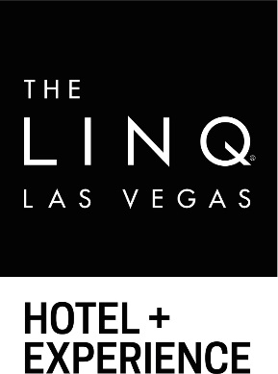

GENERAL FACT SHEET

LOCATION: The LINQ Hotel + Experience
3535 Las Vegas Boulevard South
Las Vegas, NV 89109
1-800-634-6441
TheLINQ.com
Facebook.com/TheLINQ
Twitter.com/TheLINQ
Instagram.com/TheLINQ

MEDIA ROOM: http://caesars.mediaroom.com

OVERVIEW:
The LINQ Hotel + Experience features 2,253 rooms, including the first bunk bed rooms on the Las Vegas Strip, 244 suites with two unique penthouses and 25 poolside cabana rooms. A modern Las Vegas hotel created with the connected traveler in mind, The LINQ Hotel + Experience features unique elements such as a fully-integrated self-check-in/check-out program. The convenient center-Strip location of the resort also offers guest access to The LINQ Promenade featuring more than 30 shops, restaurants and entertainment venues, along with the High Roller - the world’s tallest observation wheel at 550 feet.

The LINQ features several amenities, including the expanded 21-and-over Influence, The POOL at The LINQ, offers two pools with life-sized games and beer pong, live entertainment, food and cocktails. The hotel also features the 15,000-square-foot Spa at The LINQ and fitness center, located on the sixth floor of the main guest elevators. The state-of-the-art spa offers the only Himalayan Salt Cave therapy room on the Strip, as well as relaxation lounges, steam rooms and whirlpool areas.

CONVENTIONS:
The LINQ Hotel + Experience specializes in accommodating the needs of small and medium-sized groups with the personal attention and convenience they need. The LINQ Hotel + Experience features 31,034 square feet of flexible meeting and event space. Experience the spectacular views from the adjacent 18,000-square-foot BLOQ indoor ballroom with floor-to-ceiling windows. A diverse array of facilities—from intimate meeting rooms to The Showroom—provide for gatherings of all types.

SELF CHECK-IN/CHECK-OUT KIOSKS:
Caesars Entertainment launched the first fully-integrated self-check-in/check-out kiosks on the Strip at The LINQ Hotel + Experience in 2015. The program incorporates email, text, web, mobile app and kiosks, completely reinventing the way guests arrive and begin their stay. Upon arrival, guests can proceed immediately to the check-in kiosk to begin their check-in process, verifying their IDs and taking payment information right at the machine and either receive a printed key if their room is ready, or if it is not set up, receive an alert to return when their room becomes available.

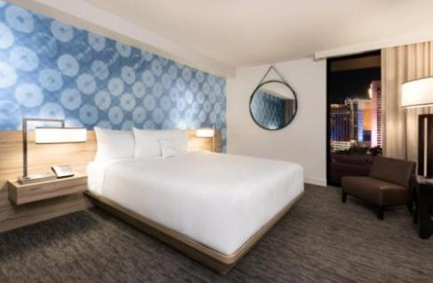
ROOMS AND SUITES:
The Deluxe and Luxury Rooms, ranging from 300-400 square feet, feature light, modern furnishings and pops of color with floor-to-ceiling windows. Select rooms boast views of the iconic Las Vegas Strip or the High Roller Observation Wheel. The centerpiece of the room designs are three distinct accent wall backdrops featuring stylized renderings of vintage Las Vegas signage, providing guests with a unique experience each time they visit the hotel.

Deluxe Rooms include:
- Beds with a lush pillow-top mattress
- 47-inch LED flat-screen TV
- USB charging station located at the convenient in-room compact commuter workspace
- Bathrooms with marbled sink and overhead rain shower
- High speed Wi-Fi available throughout the resort in all common areas, hotel rooms and gaming floor

Complimentary In-Room Fitness Carts:
The LINQ Hotel + Experience offers complimentary in-room fitness carts for all hotel guests from 7 a.m. to 7 p.m. daily. The carts include yoga mats, stability balls, fitness discs and foam rollers for a four-hour rental period. Hotel guests can call or visit Spa at The LINQ to make a reservation for the delivery.

Suites:
King Junior Suite
Approximately spanning 600 square feet, the King Junior Suite features all the amenities of a standard King room, plus a bit more space. Electronic features include two charging stations with USB ports, an iPod/iPad docking station and one 47-inch LED flat-screen TV. The room is designed with light, modern furnishings and pops of color. Each suite comes with microfiber robes.

King Suite
The 690-square-foot King Suite features a separate living room with a sectional couch, high-top table and wet bar. In-room board games and two LED flat-screen TVs (a 55-inch TV in the living room and a 47-inch TV in the bedroom) keep guests entertained, while the pops of color keep the vibe cheerful and bright. USB charging stations ensure electronic devices will always be ready to snap a picture. Fun and luxury play well together in this stylish Vegas suite.

Deluxe Poolside Cabana Room (One King Bed or Two Queen Beds)
The 300-square-foot Deluxe Poolside Cabana Room with private patio and direct pool access is the perfect spot to soak up the sun on your Vegas vacation. Skip the lines at the dayclubs and party on a private patio, and then get a quick dip in at Influence, The Pool at The LINQ. Cabana room guests enjoy waitress service from the nearby pool bar. The room also features 47-inch flat-screen TV and USB charging stations to keep devices charged for all those poolside pics.

The LINQ Penthouse
Upgrade to a 1,067-square-foot penthouse party pad with one of the two LINQ Penthouse Suites. It’s like stepping into an art gallery with eclectic wall art and unique furnishings including a chaise that demands to be in your next profile photo. Crank up the Bose speakers, play Jenga and glow-in-the-dark chess while you use the kitchenette’s spacious fridge and classy, padded leather bar to pre-game before going out. The bathroom boasts a seated vanity and walk-in rain shower. Sophistication and modern, sleek design meet in this one-bedroom suite.
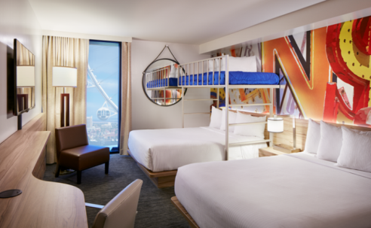
Bunk Bed Rooms:
- The 12 rooms feature two queen beds and a bunk bed loft
- Ideal for large groups of friends or families
- Rates start at $69 for the 300-square-foot room
- Electronic features include USB charging stations and a 47-inch LED flat-screen TV

DINING:
Guy Fieri’s Vegas Kitchen & Bar
Open for breakfast, lunch, dinner and late-night dining, Guy Fieri’s Vegas Kitchen & Bar features a delicious blend of casual foods including an extensive variety of burgers, wings, tacos, small bites and shareable food items. The restaurant’s extensive drink menu features 16 craft beers, in addition to the Sonoma County wine selection and a frozen tap system shot bar that will create a one-of-a kind experience for guests.

STICKY CHICKEN
This is not your neighborhood food truck. Located next to The Book, Sticky Chicken is chicken with an attitude. Enjoy monster-sized chicken sandwiches, more than 10 different wing combinations, and more, this is some of the best chicken west of the Mississippi.

Hash House A Go Go
Known for its creative menu offerings, oversize portions, unique presentation and flavorful dishes using only the freshest ingredients, Hash House A Go Go offers guests an unforgettable dining experience. The menu features their spin on traditional breakfast favorites such as their signature farm scrambles, one-pound stuffed burgers, colossal salads and innovative dinner dishes such as their Andy’s crispy Indiana style hand hammered pork tenderloin.

Off The Strip
Off The Strip has something for everyone with authentic Italian favorites, steaks, chops, burgers, seafood and more. This two-story bistro features three bars and indoor and outdoor dining with a delicious variety of hearty and healthy food.

CORNER KITCHEN & DONUTS
For casual, delicious meals, head down to the Corner Kitchen inside The LINQ. Enjoy a full menu of gourmet sandwiches, hand-tossed pizzas and other American favorites. Or if you're looking to satisfy your sweet tooth – our new donut bakery features gourmet-style donuts. Before heading out to explore the Strip, nosh on Corner Kitchen's delicious breakfast selections. Breakfast plates are packed with a full meal of eggs, meat and hash browns, or grab an English muffin breakfast sandwich. Healthy breakfast delights include steel cut oatmeal, fruit bowl and egg white Florentines. A full range of coffee and beverages include espresso, lattes, soda and hot teas.

Nook Express
Get your morning pick-me-up or late-night snack at the Nook Express at The LINQ. The small express eatery serves fresh, authentic assortments of coffee, teas, delicious pastries and small bites of satisfying tastiness daily.

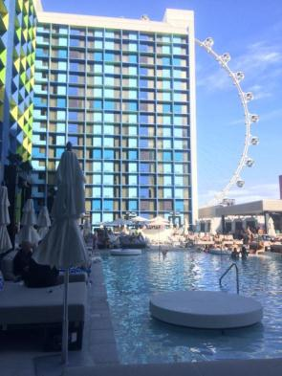
POOL:
Influence, The Pool at The LINQ provides a cooling escape with spectacular views of the High Roller observation wheel and the LINQ Promenade. This center-strip destination features a center bar lined with plasma televisions and full of signature cocktails, draught beer, frozen drinks and more. The main pool boasts a wet deck with lily pad daybeds available for rent, while the second pool is accessed from a standalone elevated deck with tables available for rent as well.
- 25 cabana rooms line the pool, offering an exclusive patio area connecting the room directly to the pool deck. The patio area includes a plasma television, sectional seating and umbrellas to keep you shaded. As a cabana room guest, “wake-up calls” are available from the cabana staff where guests can have menu items delivered directly to them at a specified time.
- Ten cabanas available for rent which include a personal electronic safe, plasma TV, USB port for phone/music player, reserved chaise lounges a refrigerator and more
- 35 daybeds line the pool deck and include a personal electronic safe, a handy compartment to keep clothing and shoes dry and umbrella holders to provide shade from the warm sun.
- Live entertainment
- The Taco Spot features delicious tacos, tostadas, bowls and more
- The fully-stocked REQ room has two pool tables, shuffle board, a foosball table and five flat-screen TVs – perfect for watching your favorite sports teams all year long. Keep an eye out for exciting parties and activations every season.

Hours: Mon. – Thurs. 9 a.m. to 5 p.m.; Fri. – Sun. 9 a.m. – 6 p.m.
Prices: Free and open to the public. Guests must be 21 years or older

GAMING:
The LINQ Hotel + Experience features an interactive and immersive gaming and entertainment environment featuring a diversified selection of experiences curated for a variety of visitors and offering adults new ways to play. The gaming floor gives guests an opportunity to try the newest experiential gaming technology on the market.

The Book
Reimagining the race and sports book and bar experience, The LINQ Hotel + Experience recently opened The Book. The latest evolution of the sports book, The Book enhances the traditional sports book model and is designed for guests to take full control of their gaming odyssey. With innovative technology, mobile and self-serve opportunities, and plenty of sports and bar games to engage in, The Book is immersive and socially-driven. The Book features twelve of the Strip’s first rentable living rooms for you and your friends on game day, featuring 98” guest-controlled televisions, Xboxes, virtual reality headsets, your own unique audio zone, bottle and drink service and more. 87 televisions can be found around The Book, some as large as 98”, as well as a self-serve beer wall.

CASINO ENVIRONMENT:
DIGITAL ART EXHIBITION BY REFIK ANADOL: Among the world’s largest and most interactive environmental art installations, DATALAND: LINQ is a synthetic reality experience woven throughout the LINQ casino interior and exterior. Created by world-renowned artist Refik Anadol, his first-ever in Las Vegas, the dazzling digital art installations are displayed on a variety of digital canvases throughout the casino including two main entrances and 3-dimensional LED sculptural elements on the ceiling. The overall installation is reactive and changes in a choreographed manner as guests enter the spaces, allowing visitors to be an active part of the art experience.

TRADITIONAL GAMING WITH A TWIST: You can find a variety of slot games and more, including those featuring your favorite characters from TV and film. The LINQ’s new enhanced casino lighting system celebrates jackpots in the casino through advanced lighting and sounds effects. If you prefer table games, we’ve got you covered with roulette, craps, blackjack and more.

PULSE ARENA: Located near The Book, Pulse Arena combines Interblock’s luxury electronic gaming machines with an immersive audio-visual entertainment experience.

BARS AND NIGHTLIFE:
RE:MATCH
RE:MATCH is the all-new integrated Strip-side bar featuring indoor/outdoor seating where guests can enjoy cocktails while taking in the sights.

3535
3535 is a trend seeker’s destination lounge, featuring a hand-crafted selection of infusion cocktails; barrel aged spirits, wine by the glass and a vast selection of premium and craft beers. 3535 is an all-encompassing space with a multitude of experiences in one with casino gaming, bottle service, beverage cart offerings and a variety of entertainment including weekend DJ sets.

Catalyst Bar
Located inside The LINQ Hotel + Experience, Catalyst Bar is open around the clock and puts a spin to your traditional cocktails with flair bartenders serving you up in style.

O’Sheas Casino
With a raucous atmosphere traditional of an Irish pub, O’Sheas is a destination that’s pure fun and features the same gaming tables, beer pong and drink specials that made the original so popular. In its heavily social and dynamic environment, enjoy more than 60 kinds of beer, table games, and a lively outdoor bar and nightly entertainment at its Irish-inspired stage area featuring live performances.

ENTERTAINMENT:
Mat Franco
Mat Franco, the first magician to win NBC’s America’s Got Talent, brings his captivating, hold-on-to-your-seat illusions to the heart of the Las Vegas Strip. For his first-ever Las Vegas headlining residency, Mat offers a fresh, fun, and feel-good twist on magic that defies all expectations. In a full-scale production built on brand-new, never-before-seen material, Mat delivers his most spectacular performance yet—but keeps his love of getting up close with the crowd at the heart of every show. With his signature brand of breezy humor, Mat mixes his amazingly inventive and always stunning magic with crowd-guided improv to create a once-in-a-lifetime adventure that’s completely unique to each audience and entirely unforgettable.

The Bronx Wanderers
United by their passion for great music, The Bronx Wanderers are helmed to perfection by charismatic master entertainer Vinny Adinolfi, who is a former chart-topping record producer. He is joined on stage by his two sons - Vinny “Vin. A” Adinolfi III, an Italian Brian Wilson who sings, arranges and plays several different instruments, and drummer extraordinaire Nicky Adinolfi – as well as a killer hand-picked backup band, including Joe Bari, Fernando Tort and David Braun. The show covers all musical bases, and hits an out-of-the-park home run with audiences of all ages every night. This is more than just an amazingly talented family band. The Bronx Wanderers are a heart, a sound, a feeling and a harmony that goes right to the heart of the crowd, getting them singing along and up on their feet like no other show can do

THE LINQ Promenade
The LINQ Promenade is an open-air retail, entertainment and dining district, anchored by the world’s tallest observation wheel, known as the High Roller and the first zipline on the Las Vegas Strip, FLY LINQ. Located at the heart of the world-famous Las Vegas Strip and surrounded by approximately 10,000 hotel rooms, The LINQ Promenade is situated between The LINQ Hotel + Experience and Flamingo Las Vegas, directly facing Caesars Palace. An estimated 20.4 million visitors pass by this coveted space each year.
# # #

